**Solid Mechanics Coursework**

**(****Three-Point Bending/ Flexural Test)**

**CHENRUI MAO**

**SECTION A**

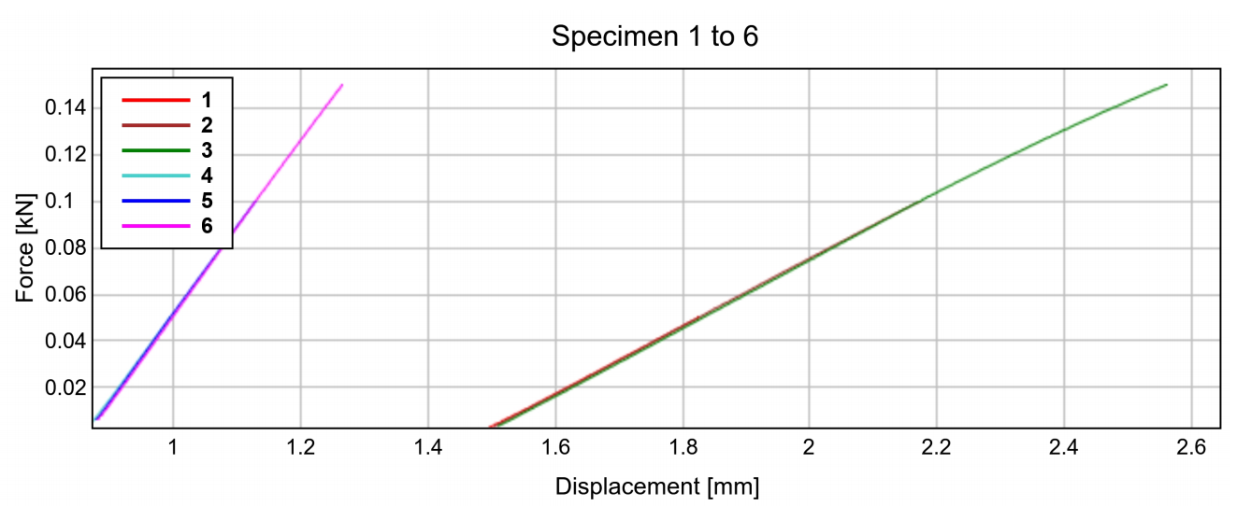

Displacement-Force curves for

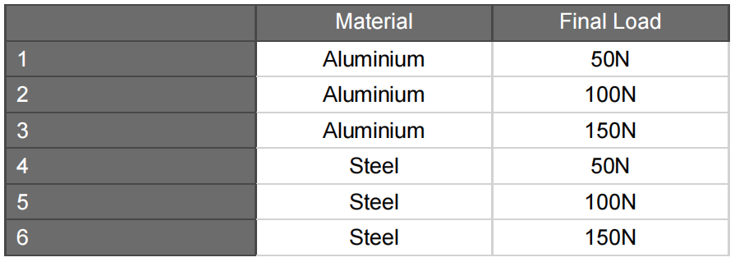

**1.Calculation**

Substitute the height, thickness and width of the specimens to obtain the moment of inertia I=4.5 $×{10}^{-11}$.We find the zero point of the curve by means of the displacement versus force curve diagram and obtain the actual displacement, using the formula () to find the value of $E_{1}$, $E_{2}$, $E_{3}$ and $E_{exp}$ for mild steel and aluminium respectively.

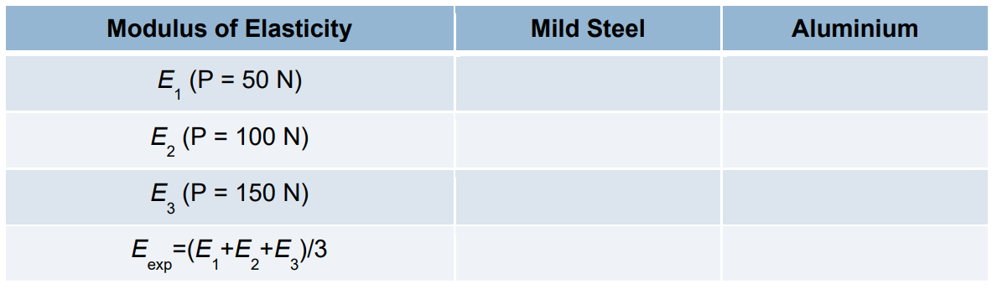

65.8GPA

67.3GPA

66.7GPA

174.7GPA

174.4GPA

170.4GPA



66.6GPA

173.2GPA

**2.Summary**

From the experimental results it can be seen that the modulus of elasticity of mild steel is much greater than that of aluminium, precisely because the deflection of aluminium is greater than that of mild steel under the same load.

**SECTION B**

**1.Calculation**

Using the results from section B, we substitute $E_{exp}$ into equation $δ_{max}=δ_{c}=\frac{PL^{3}}{48EI}$ to obtain the maximum deflection of the aluminium [specimen](javascript:;) and mild steel [specimen](javascript:;) under different loads ( P=50; P=100; P=150 ).

For mild steel: $δ_{max}=δ_{c}=\frac{PL^{3}}{48EI}$ = $\frac{50×{0.1}^{3}}{48×173.2×{10}^{9}×4.5×{10}^{-11}}=0.134×{10}^{-3}$

$δ_{max}=δ_{c}=\frac{PL^{3}}{48EI}$ = $\frac{100×{0.1}^{3}}{48×173.2×{10}^{9}×4.5×{10}^{-11}}=0.267×{10}^{-3}$

$δ_{max}=δ_{c}=\frac{PL^{3}}{48EI}$ = $\frac{150×{0.1}^{3}}{48×173.2×{10}^{9}×4.5×{10}^{-11}}=0.401×{10}^{-3}$

For alunimium: $δ_{max}=δ_{c}=\frac{PL^{3}}{48EI}$ = $\frac{50×{0.1}^{3}}{48×66.6×{10}^{9}×4.5×{10}^{-11}}=0.348×{10}^{-3}$

$δ_{max}=δ_{c}=\frac{PL^{3}}{48EI}$ = $\frac{100×{0.1}^{3}}{48×66.6×{10}^{9}×4.5×{10}^{-11}}=0.695×{10}^{-3}$

$δ_{max}=δ_{c}=\frac{PL^{3}}{48EI}$ = $\frac{150×{0.1}^{3}}{48×66.6×{10}^{9}×4.5×{10}^{-11}}=1.042×{10}^{-3}$

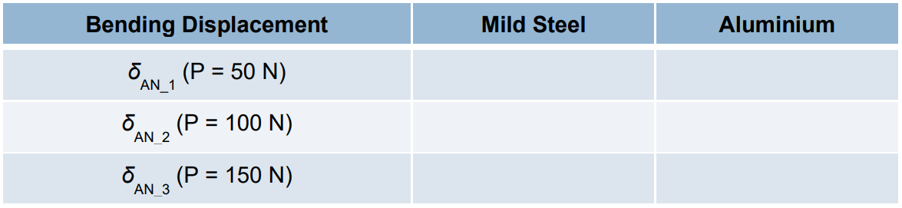

0.348mm

0.401mm

0.267mm

0.695mm

1.042mm

0.134mm

1. **Summary**

The average value of the modulus of elasticity obtained from the three experiments was substituted into the formula to reduce the experimental error. Then we can then obtain the displacement that occurs in the sample under different loads.

**SECTION C**

**From ANSYS, we can get**

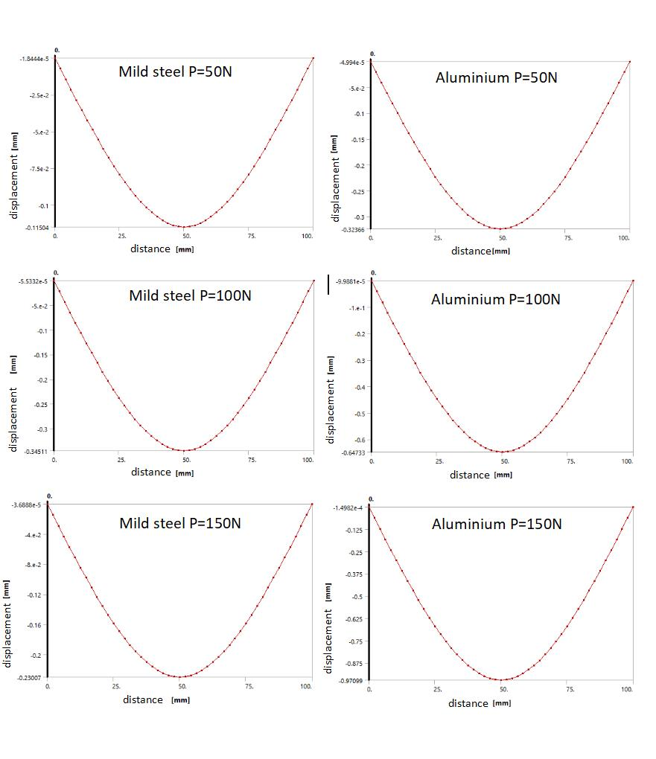

**1.Calculation**

By using Displacement versus Position curves, we can easily determine the maximum deflection of the sample.

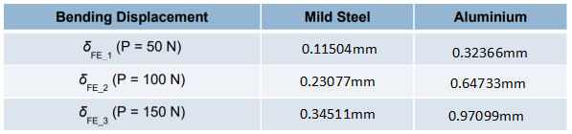

**2.Summary**

We can get six pictures of Displacement versus Position curves about the mild steel sample and aluminium sample respectively through the simulation analysis of ANSYS, they show the distribution relationship of deflection on the sample under different forces of loading.

**SECTION D**

By comparing the experiments in section B section C, it was found that the experimental maximum deflections were greater than the maximum deflections obtained by ANSYS. And the difference of the mild steel beam is greater than that of aluminium.

There are several possible reasons for the difference:

1. The slope of the Displacement versus Force curves is not accurate because the machine is not well calibrated.
2. Inadequate machining accuracy of the part, which makes the internal part uneven and the centre of mass does not exactly coincide with the geometric centre.

There are some suggestions that might reduce the experimental differences to improve the [experiment](javascript:;).

1. Use highly accurate machined metal beams to avoid uneven densities and complex stresses within the sample.
2. Place the sample squarely in the apparatus to reduce errors